Hello! You are trying to install a discord bot. To activate all functions, you need a reddit account, registered reddit api and a discord account.

How to start the bot for the first time:

1. Go to https://www.reddit.com/ and click login (if you have an existing account) or sign up (If you haven't got an account)

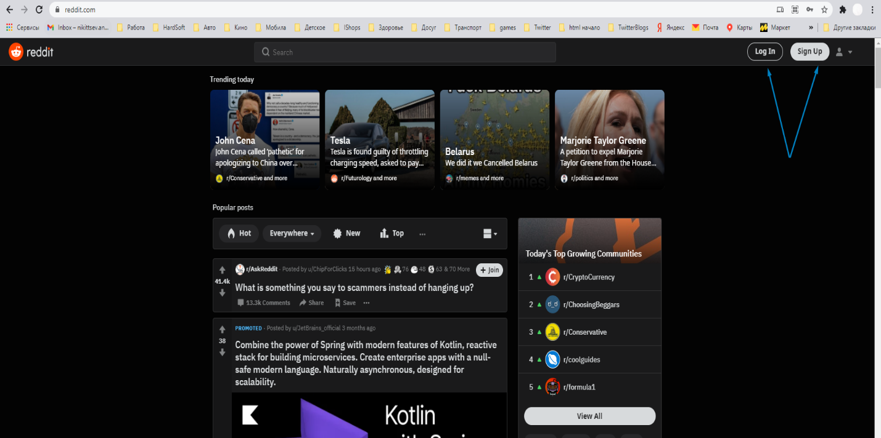

2. After filling in your email you have a window, where you need to fill in a username and password for your account. These username and password are required for the bot, so remember it. 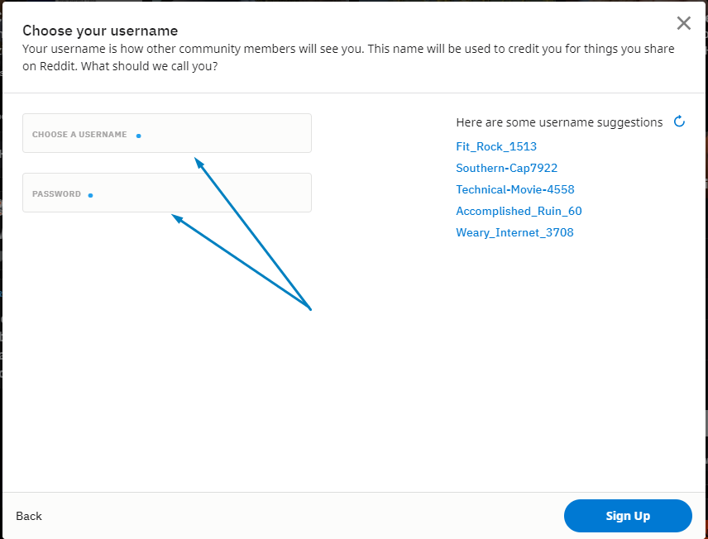

3. After you registered go to https://www.reddit.com/prefs/apps and scroll down to the bottom of the web page.

4. Click on "Create app

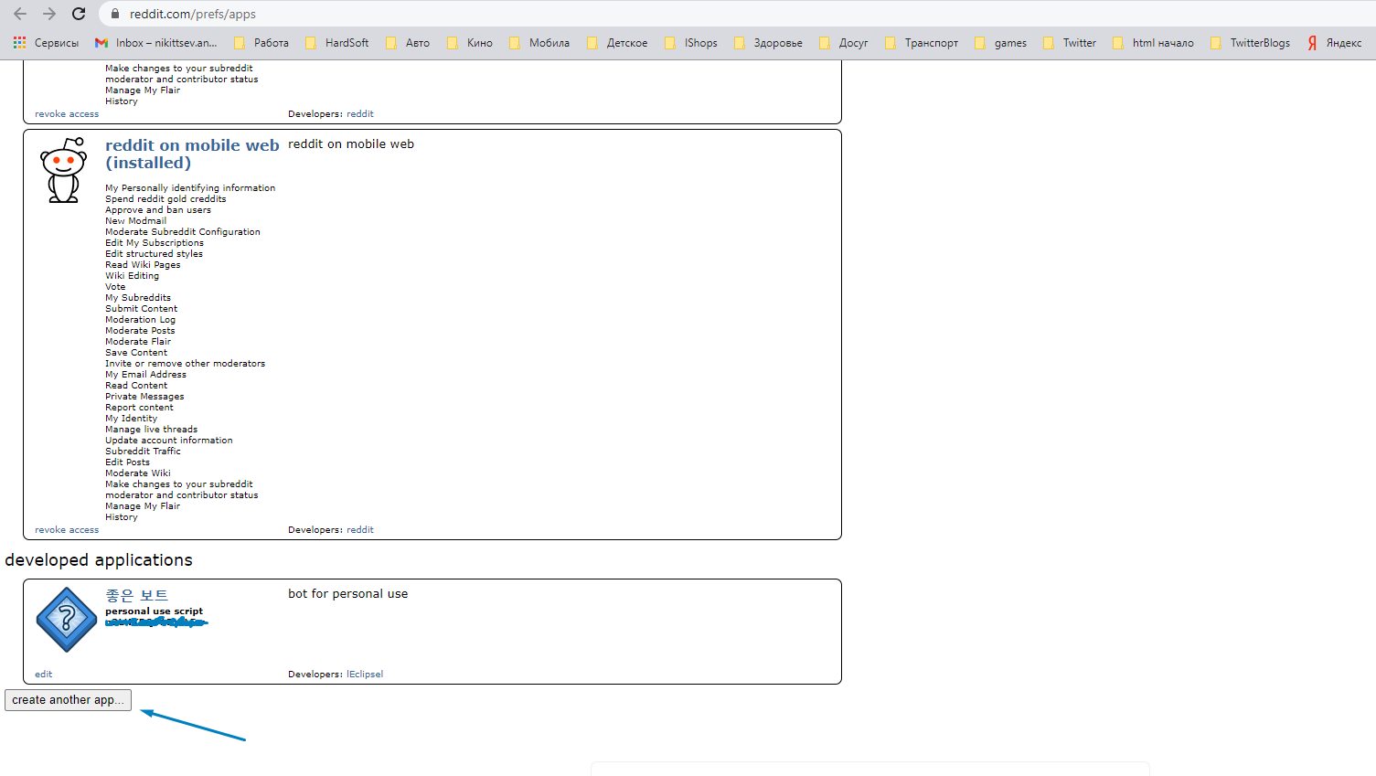

5. Then you need to name your App (can be any name), choose script option, add description (can be any description) and add redirect uri (url for any of your social networks). After it click "create app"

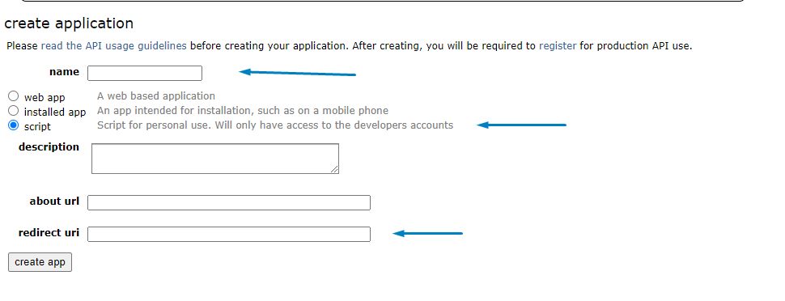

6. Next you will see this window, in which there is a secret token and client id. You need to remember them and you should not tell secret token to anyone.

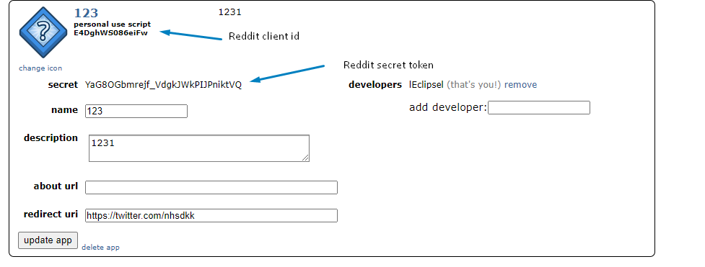

7.Go to https://discord.com/developers/applications and login to discord account.

8.Click on "New application" and type a name (whatever you want)

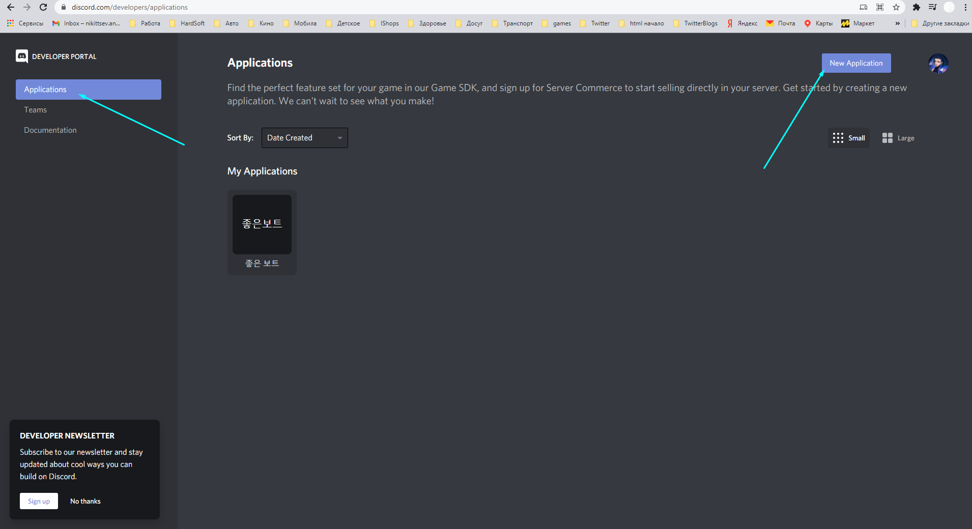

9.Click on Bot in the left menu and then click add bot

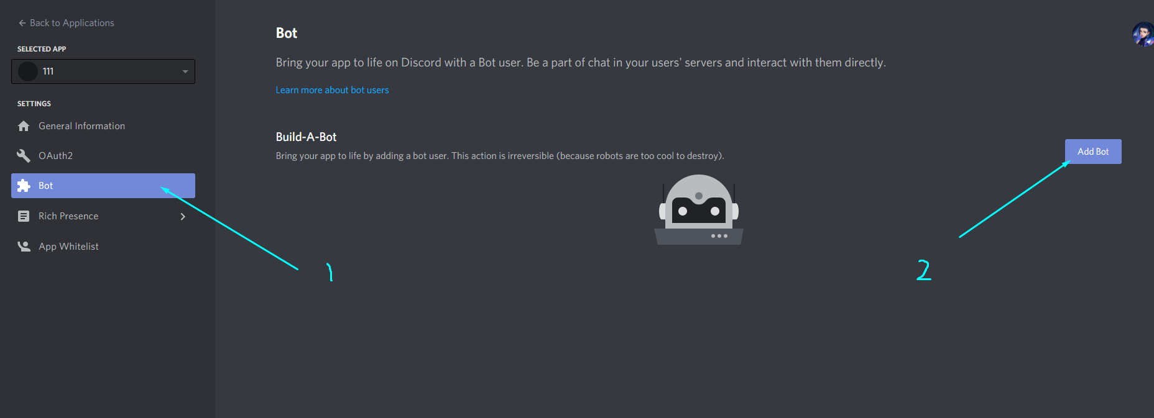

10.Click on copy button to copy the token and save it

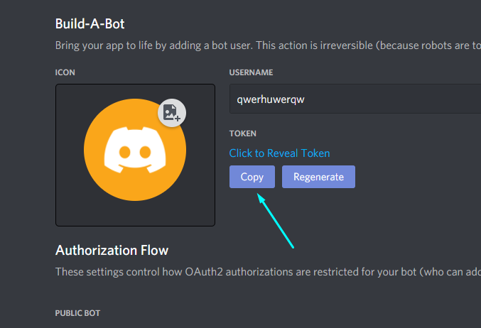

11.Go to «OAuth2" and in "scopes" section put a tick on a bot and copy the url

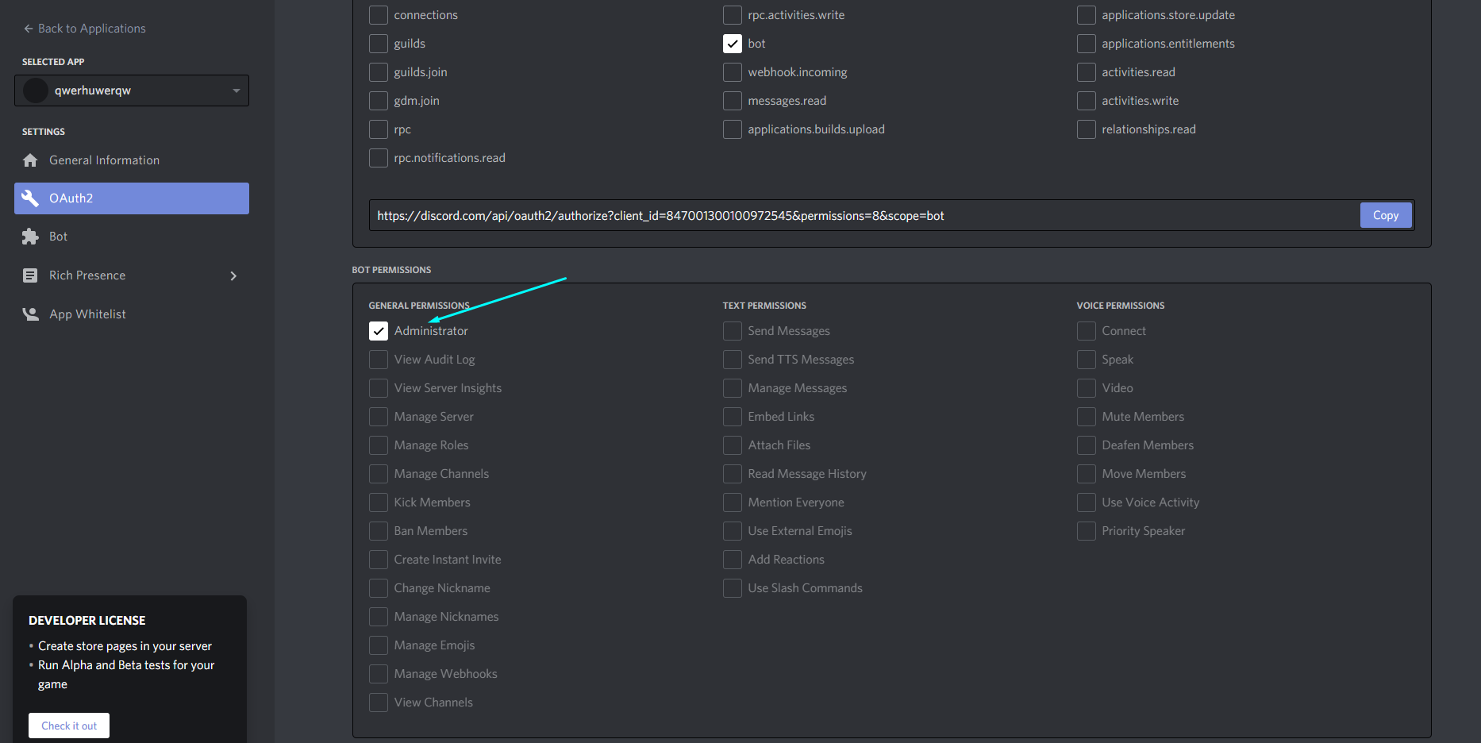

12.Scroll down to a bot permission and put a tick on Administrator

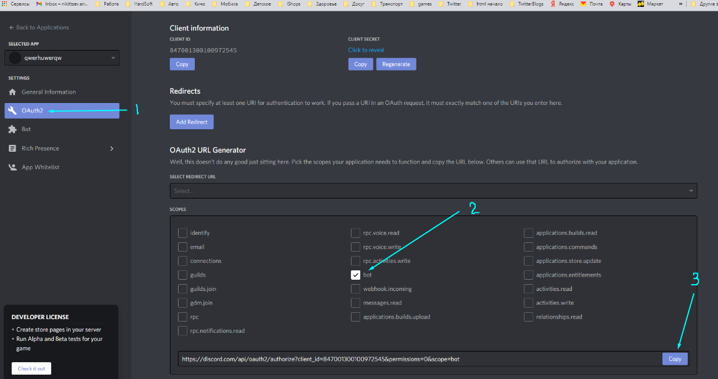

13.Go to the url you copied earlier and choose a server for your bot.

14.You need to start startup program and enter your reddit login, password, secret token, client id and discord token. In future if you need to update this data just start startup program and it will update it. 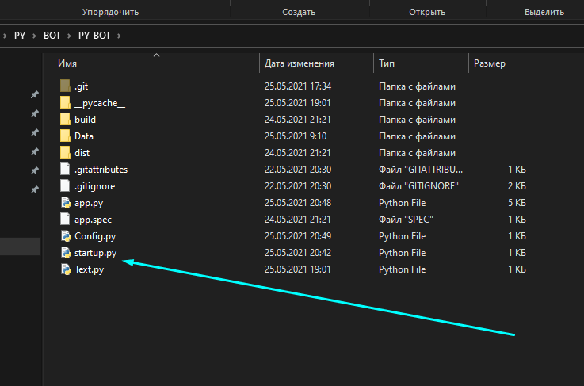

14.Then you will be ready to start the bot. Just open app.py and wait for message.